Dear HGSE Students,

I hope you are doing well as you acclimate yourself to HGSE and prepare for the Fall semester ahead! This email is intended to equip you with some of the knowledge and resources you will need as you begin the Fall semester at HGSE. Please take into consideration that this is a lot of information to digest and that it may not be relevant or useful until you start the registration process later this month; a copy of this communication will be uploaded to our Messages to Students page starting tomorrow. The Registrar team is available to assist you if you encounter any roadblocks or have any questions; please visit our website for in-person and virtual hours or email us at registrar@gse.harvard.edu.

The topics covered in this email include:

- My.Harvard Check-in process
- Cross-registration
- HGSE courses
- Course previews
- Course enrollment
- Grade option
- Credit limits
- Enrollment event timeline

My.Harvard Check-In

Fall semester Check-In in my.Harvard started on Monday, August 8. You will be able to complete the check-in process by following these steps. The deadline to check-in within my.Harvard is Friday, September 2. After September 2, students will be allowed to do late check-in through Monday, September 19 at which time check-in will close. All students are required to check-in for the fall semester. When you have completed the Check-in process, you will be able to move forward to enroll in classes.

Cross-Registration
Like HGSE course registration, cross-registration into any of the other Harvard schools and MIT is done through my.harvard. Please note that classes at other Harvard Schools start as early as Wednesday, August 31. If you are interested in cross registering into the Fletcher School of Law and Diplomacy at Tufts University, please submit this form. Please take a few moments to review the cross-registration process with other schools at Harvard. Also, visit our Cross-Registration page for additional information.

Cross-Registration Enrollment Events timeline

Please see below for a timeline of key fall Cross-Registration enrollment events:

- Monday, August 15: Add courses to your Crimson Cart Opens – This means that you can start adding courses at other Harvard Schools and MIT to your Crimson Cart. This will allow you to validate and submit petitions for instructor permission courses. Holds do not impact your ability to add courses to your Crimson Cart and submit petitions!
- Wednesday, August 31: Cross-registration classes at other Harvard Schools – Please note that classes at other Harvard Schools start as early as 8/31/2022. Please visit other Harvard Registrar’s Offices for more information about their Academic Calendar.

HGSE Courses

Courses offered during academic year 2022-2023 are viewable in my.Harvard. Please be aware that development of the course list is still in progress and that additions and changes will be made right up until the time of course enrollment. For that reason, it is a good idea to check Course Search in my.Harvard frequently.

Course Previews Sessions

Course previews at HGSE classes occur in two parts in advance of course enrollment:

- Course Previews, Part I: By viewing 8-10-minute pre-recorded videos created by the course instructors and posted to their course websites. These videos will be made available to students starting on Friday, August 26.
- Course Previews, Part II: By attending live, 25-minute question and answer sessions during schoolwide Orientation week. Fall Q&A sessions will be scheduled on Tuesday, August 30, and Wednesday, August 31. The preview schedule will be posted to my.Harvard on Friday, August 26. These live sessions will also be recorded and posted to course websites.

HGSE Course Enrollment

Once you have completed check-in (as described above), you may begin the course enrollment process when registration opens. Please see the table below with HGSE enrollment categories for Academic Year 2022-2023. Please visit our Fall Registration 2022 page for detailed information of the course enrollment process and deadlines. For additional information about the Lottery-based enrollment process, please click here. If you have not enrolled in any course prior to 11:59 p.m. ET on Friday, September 2, you may enroll late, but a $50 late fee will be assessed.

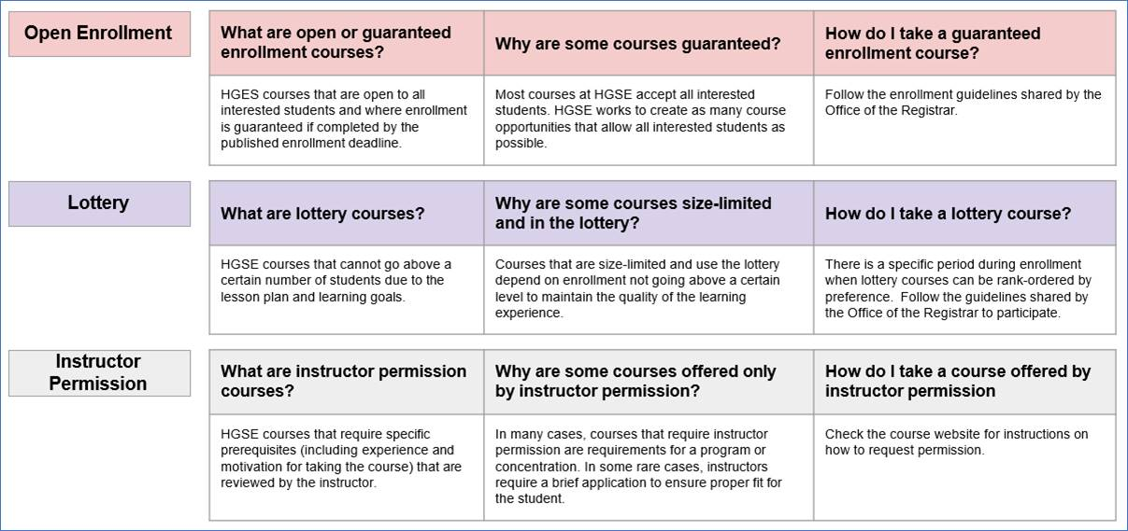

Grade Options

Students are expected to indicate their grade option (letter grade or satisfactory/no credit) for each course selected at course enrollment. As you plan out your course of study for the year (or for two years if part-time), please keep in mind that, in general, Ed.M. students must take at least 21 credits for a letter grade.

Credit Limit

Full-time students may take no more than 20 credits per semester (fall and spring). Part-time students may take no more than 10 credits per semester (fall and spring).

Enrollment Events timeline

Please see below for a timeline of key fall enrollment events:

• Monday, August 15: Add courses to your Crimson Cart Opens – This means that you can start adding courses to your Crimson Cart. This will allow you to validate and submit petitions for instructor permission courses. Please note that you will not be able to enroll into HGSE courses until open-enrollment day: Wednesday, August 31 at 12:01am ET. Holds do not impact your ability to add courses to your Crimson Cart and submit petitions!

• Wednesday, August 24: Lottery-based Enrollment Opens (rank your choices) – This means that you can start ranking your course(s) preferences. You can submit and rank your preferences until Tuesday, August 30 at 12:00pm ET. Please note that the lottery-based enrollment is NOT a first-come, first-served process. All ranked preferences will be run via an algorithm that randomizes choices and does not take time of submission into account. In other words, your ranked preferences are treated equally if submitted between when the event opens and when it closes on Tuesday, August 30 at 11:59am ET.
• Friday, August 26: Course Previews Part I (see details above).
• Tuesday, August 30, and Wednesday, August 31: Course Previews Part II (see details above).

• Tuesday, August 30, 11:59pm ET: Lottery-based Enrollment Deadline - The lottery-based enrollment event process will run that afternoon and results will be communicated beginning at around 6pm. Please note that if you are selected as part of the lottery-based enrollment process, you will be auto-enrolled, and no further action is needed from you. Enrollment and registration holds are ignored for the lottery-based enrollment event; however, you have until 12:00pm ET on Friday, September 2 to clear your holds or lottery-based enrollments will be dropped. Please visit our Lottery-Based Enrollment page for detailed information about this process.

• Wednesday, August 31: Open enrollment begins –You can start enrolling in courses that are in your Crimson Cart. This includes instructor permission courses with approved petitions. Please note that if you have any enrollment and registrations holds at this point, it will prevent enrollment.

• Friday, September 2, 5pm ET: Check-In and HGSE Course Enrollment deadline –After this deadline, all courses will require instructor consent.

Contact Us

If you have any questions, please contact us at registrar@gse.harvard.edu.

Have a great semester!

Miguel Sahagun, Ph.D. | Registrar of the Harvard Graduate School of Education
Harvard University | Longfellow Hall | 13 Appian Way | Cambridge MA 02138 | registrar.gse.harvard.edu | he him his | Hablo español

