1. From the Student Portal, click on Student Home followed by Personal Info.  Click on Edit Addresses:

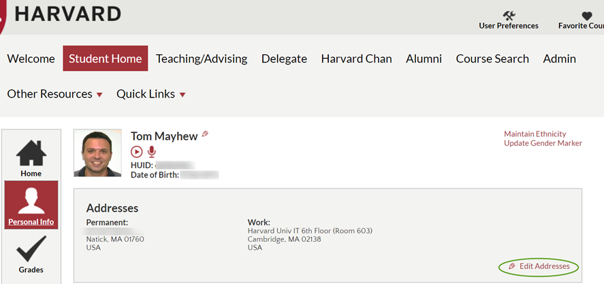

1. Click on the Add a New Address button:

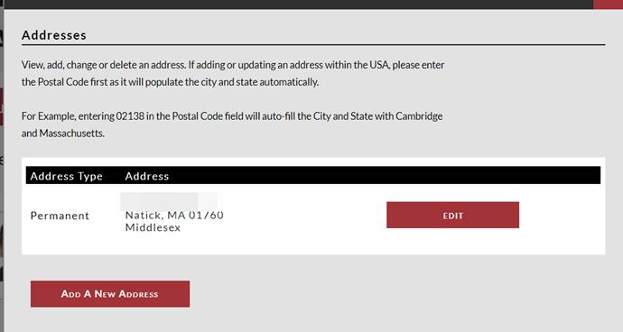

1. Enter the new address and click OK

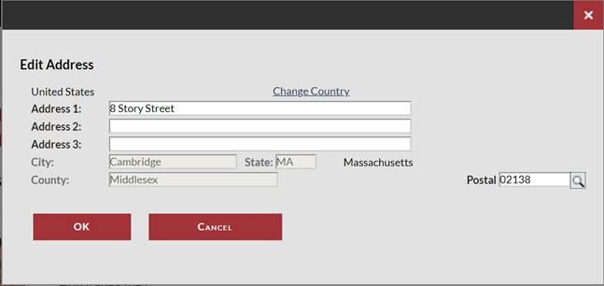

1. Select “Diploma” the Address Type and Click Save:

